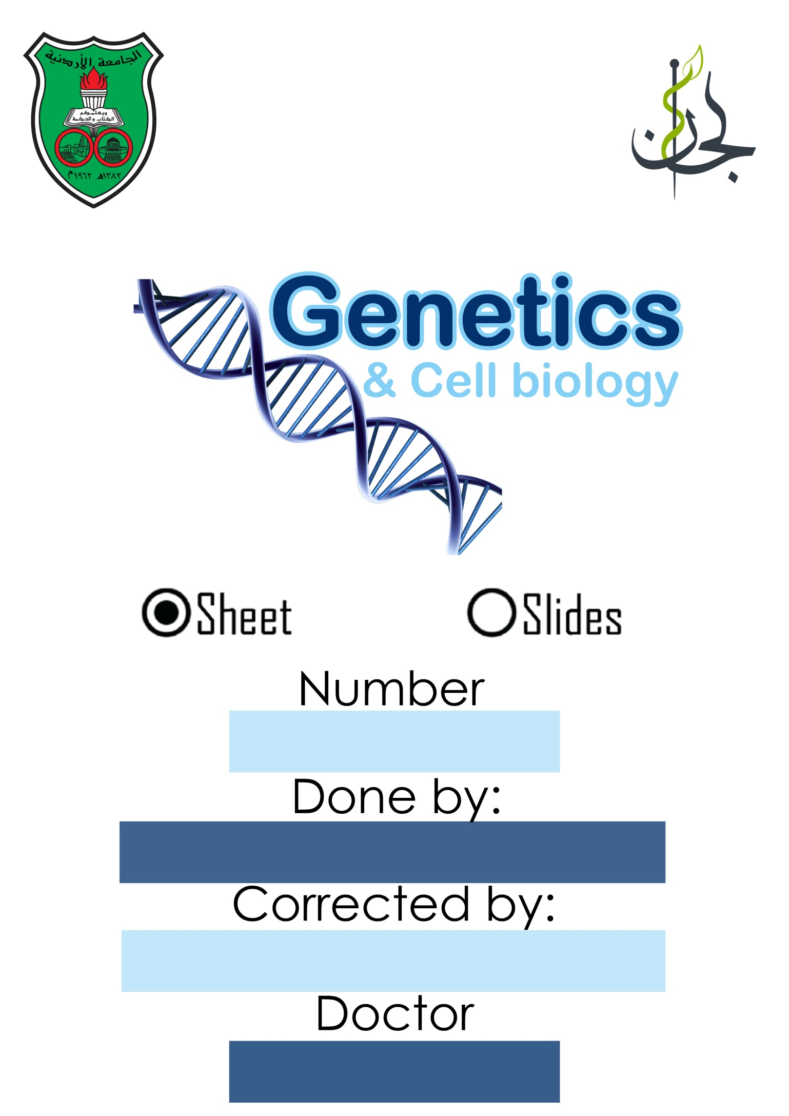

Bilal Azab

Kamal Nasir

Ola Al-juneidi

5

The lecture starts at 21:30min

Translocations

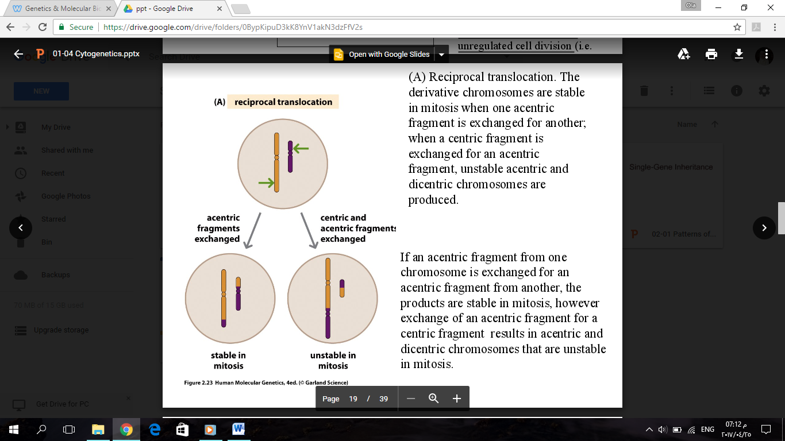Translocation is a crucial and important mechanism for many clinical outcomes.

* **Reciprocal translocation:** exchange of genetic material between non-homologous chromosomes.
* If the centromere is still intact as one centromere, the translocated chromosomes are not lost when the cells divide.
* If the outcome of the translocation is a chromosome either missing a centromere or is having more than one centromere (dicentric), it will be unstable mitotically.

In reciprocal translocations, I have no loss or gain of genetic material but it is rearranged. When gametes are made, any possible combination of a gamete that is carrying one chromosome from each number is possible. The two un-translocated could go together in one cell (gamete #1) and the two translocated with each other (gamete #2) and so on (4 possible combinations).

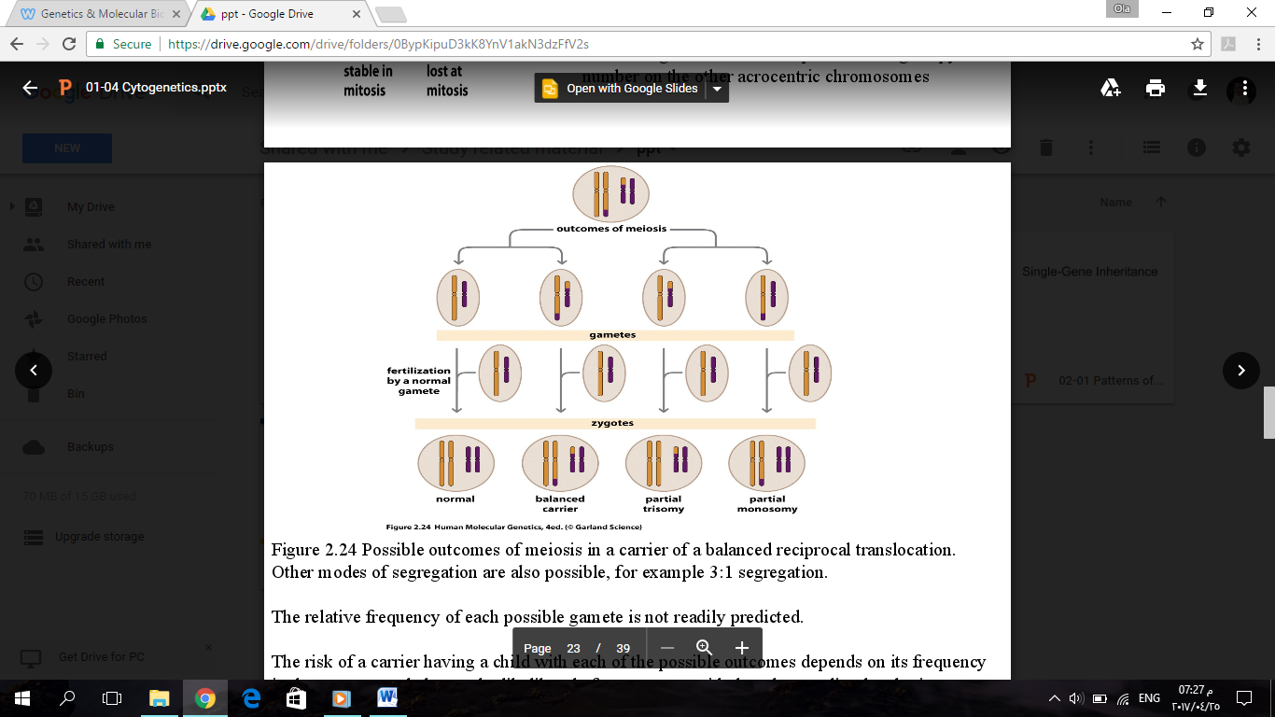

1

2

3

4

**When gamete1 is fertilized, the zygote will be normal.

**When gamete2 is fertilized, the zygote will be a balanced carrier; there is a translocation but with no gain or loss of genetic material.

**In gamete3, part of the purple chromosome is missing with an extra part from the brown one. Thus, after fertilization, the zygote will have partial trisomy for the brown chromosome and partial monosomy for the purple chromosome.

**The same thing applies for gamete4 but the zygote will have partial trisomy for the purple chromosome and partial monosomy for the brown chromosome.

**Partial** trisomy means that there is an extra copy of part of a chromosome.

**Partial** monosomy means that there is a missing copy of part of a chromosome.

Partial trisomy means that there is an extra copy of part of a chromosome.

Partial monosomy means that there is a missing copy of part of a chromosome.

* 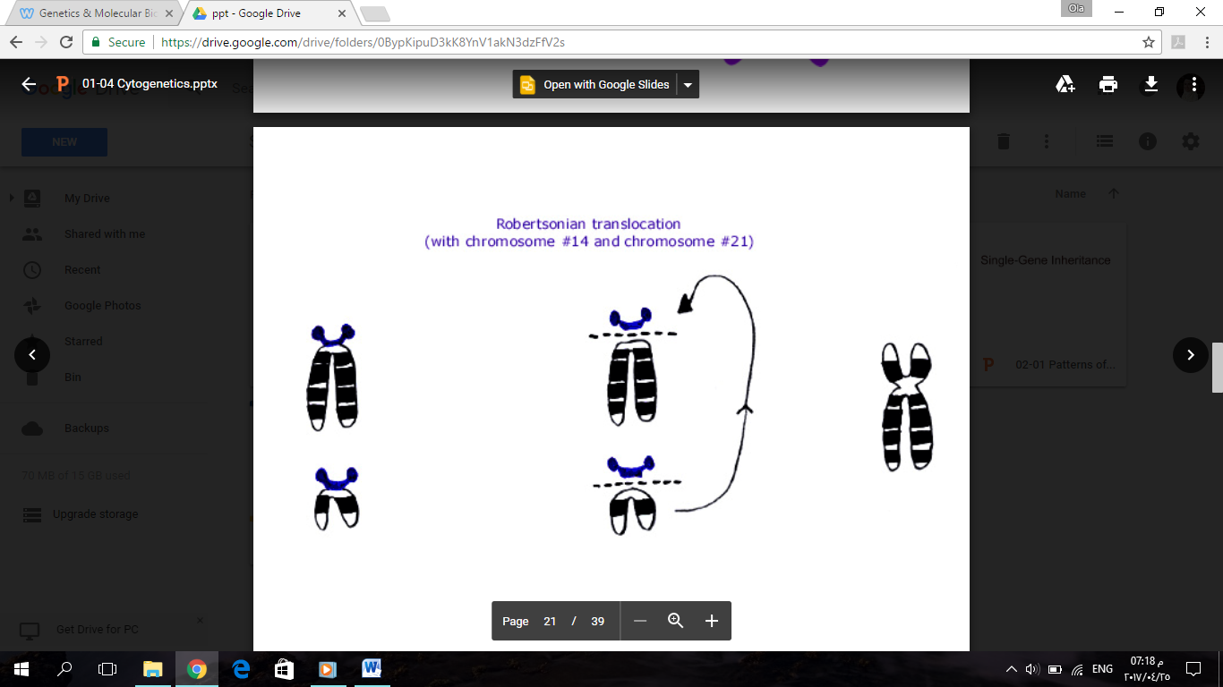**Robertsonian translocation:** is a translocation of acrocentric chromosomes (13, 14, 15, 21, and 22). In both acrocentric chromosomes, the p arm is cut and lost in mitosis without any effect on the phenotype. The q arms of both acrocentric chromosomes fuse together. This results in a dicentric chromosome that is nevertheless stable in mitosis. Example: chromosomes 14 and 21.

The q arm of the 1st chromosome

The q arm of the 2nd chromosome

A patient with this translocation is clinically normal because he has the q arm of 14 and the q arm of 21 fused together; there is no significant genetic material that is missing.

The problem happens when this patient produces gametes. Look at the figure below.

**Note:** The relative frequency of each possible gamete is not readily predicted. The risk of a carrier having a child with each of the possible outcomes depends on its frequency in the gametes and also on the likelihood of a conceptus with that abnormality developing to term.

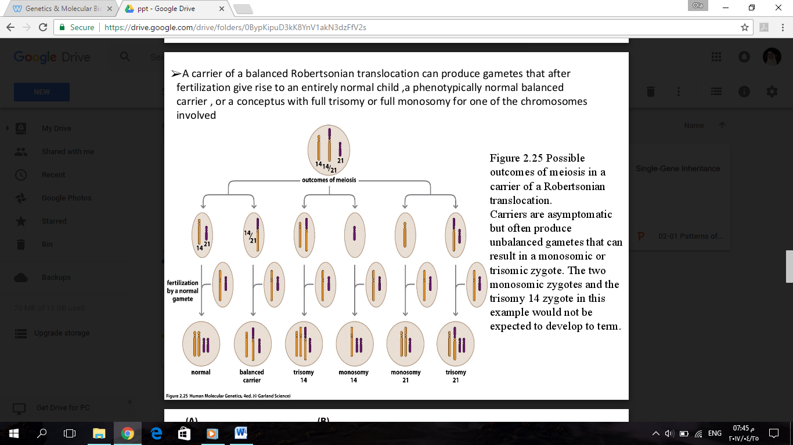

I

II

III

IV

V

VI

This figure shows all the possible scenarios:

* Chromosomes 14 and 21 could go together in one gamete (gamete no.I) and the translocated chromosome goes to the other (gamete no.II).
* Chromosome 14 could go with the translocated chromosome (gamete no.III) and chromosome 21 stays alone (gamete no.IV). Here, gamete III has extra genetic material from chromosome 14.
* Chromosome 14 goes in one gamete (gamete no.V) and chromosome 21 goes with the translocated chromosome in the other (gamete no. VI). Here, gamete VI has two q arms of chromosome 21♦.

When fertilization with a normal gamete happens, the possibilities of the zygote (2n) are: - Normal

- Balanced: It has chromosome 14, its homologue, chromosome 21, and its homologue.

- Trisomy 14: has 3 copies of chromosome 14♦. Chromosome 14 is normal.

- Monosomy 14

- Monosomy 21

- Trisomy 21

♦ Remember: a q arm of a translocated acrocentric chromosome is equivalent to the whole chromosome

*When do I see a normal patient but is a balanced carrier?

- Multiple cases of children with chromosomal abnormalities.

He is a balanced carrier, but when he forms gametes, two q arms with another chromosome. For example, parents who have two children with Down syndrome are suspected to be balanced carriers.

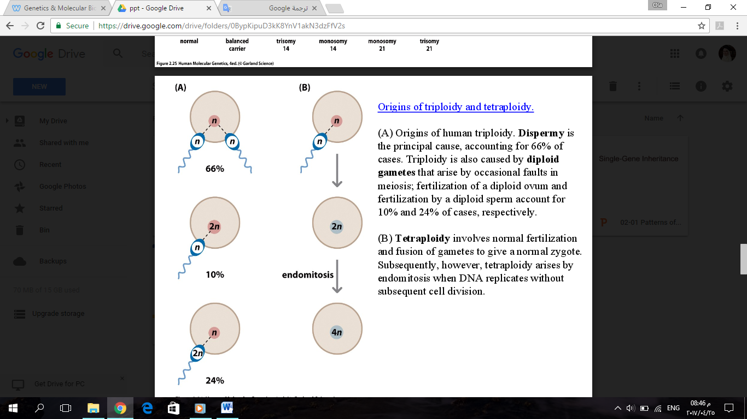

Polyploidy:

Multiples of n:

* 3n→ **triploidy**
* 4n→ **tetraploidy**

(A) **Triploidy**: three sets of chromosomes (69 chromosomes).

- 66% of triploids are due to the fact that two sperms fertilized one egg by mistake.

- 10% of a chance of having an egg with 2n fertilized by a normal sperm.

- 24% of a chance that the sperm is having 2n.

It is either:

*so most of the time it is a problem with the sperm.

* **Maternal triploidy:** the cause is maternal; the egg itself is 2n.
* **Paternal triploidy:** 2 sperms together (*dispermy*) or a sperm carrying two sets of chromosomes (2n) (*diandry*).

(B) **Tetraploidy**

A normal sperm (1n) fertilizes a normal egg (1n), and the fertilized zygote is 2n. But when mitosis is happening, the nucleus is dividing giving two nuclei (2n each>> 4n) but the cytoplasm didn't split between them. So, the two nuclei are still together with 4n. This is called ***endomitosis***.

*What happens when there is pregnancy with a 3n embryo?

The most common **clinical signs** are (if there is a fetus):

1. severe intrauterine growth retardation
2. macrocephaly (a condition in which the head is abnormally large)
3. total syndactyly of third and fourth fingers
4. CNS, heart and renal defects.

21:30-31:30

***Pregnancy mole*** or ***Hydatid form mole***:

There is an abnormal growth in the uterus. It is benign (not a tumor) and it looks like a bunch of grapes which are due to triploidy.

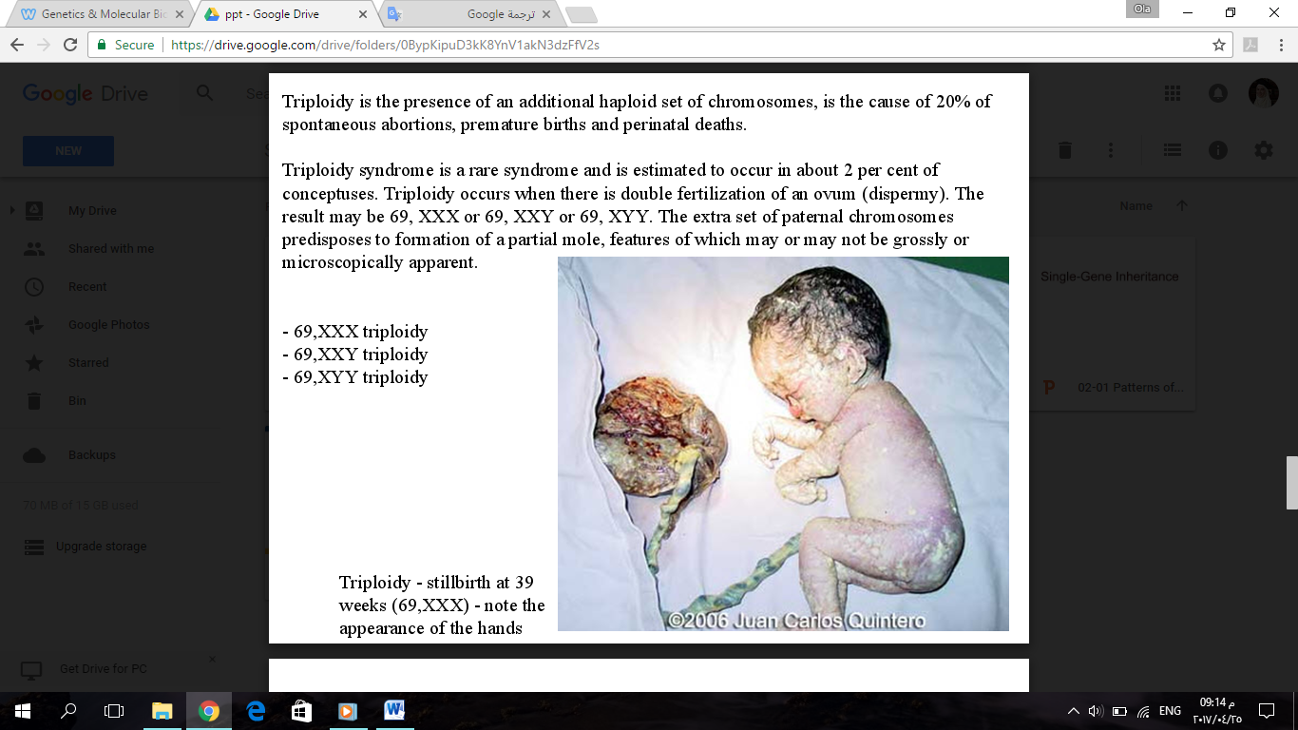Triploidy happens in 2% of conceptions. This is really high as a number if you think about it. It can give:

- 69, XXX triploidy

- 69, XXY triploidy

- 69, XYY triploidy

It is eventually lethal.

Triploidy - stillbirth at 39 weeks (69, XXX) - note the appearance of the hands.

**Scenario1: Normal conception**

What should normally happen, one set of chromosomes comes from the sperm and the one set of chromosomes from the egg resulting in a zygote with two sets of chromosomes after fertilization, one from each parent. The fetus is viable.

**Scenario2: Partial mole**

2 sperms could fertilize one egg (23*3=69 chromosomes); having one maternal and 2 paternal sets of chromosomes. The fetus will not be viable; it will die.

**Scenario3: Complete mole** >> pregnant but no fetus

One of the possible scenarios: A sperm comes in (23 chromosomes) and the nucleus of the egg will be removed for some abnormal reasons. Because the sperm is carrying 23 chromosomes and it is now a zygote, it needs to rescue what's happening. So, this zygote which is missing one set of chromosomes, will synthesize a whole complement of chromosomes. This results in 46 chromosomes, all coming from one individual, and the sequence of homologous chromosomes is identical. This is called ***chromosomal rescue***. In this case there is two sets of paternal chromosomes (no maternal) and there is no fetus; only a mole.

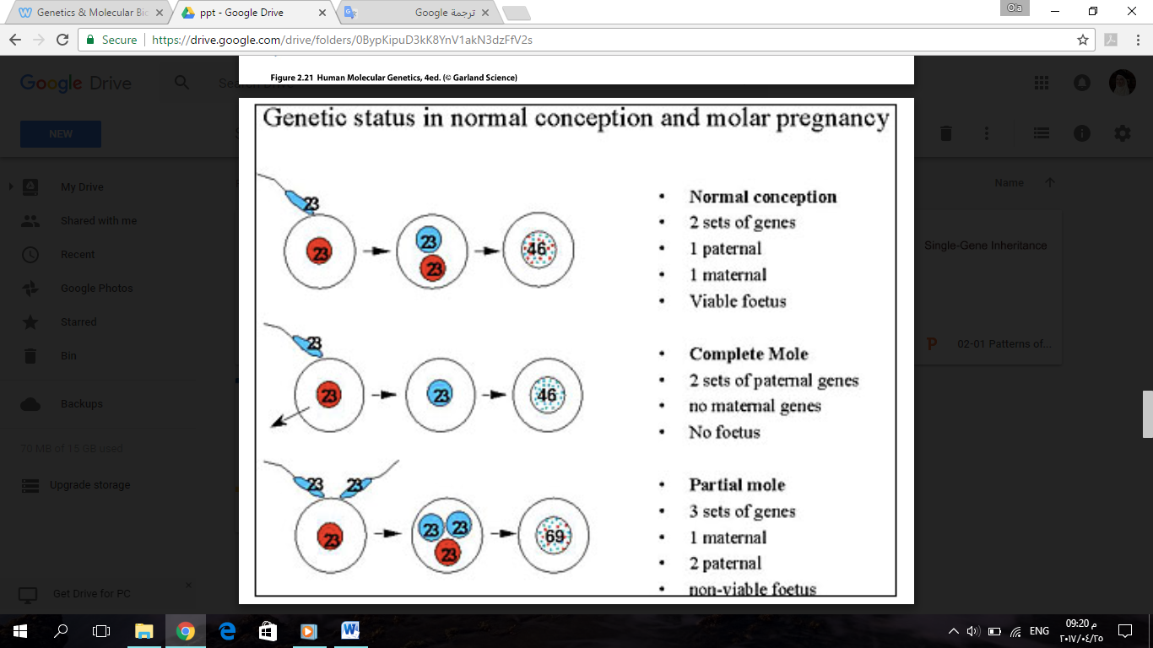

*Side note:*

Twins are either:

**Identical:** one zygote. When this zygote is undergoing mitotic divisions, one of the cells will separate and grow as a fetus. The rest of the cells grow as another fetus. The DNA sequence for both fetuses is the same. However, they are not 100% genetically identical due to epigenetics.

**Not identical:** two eggs are produced from both ovaries by chance, and each of them is fertilized by a different sperm. The genetic complement of both fetuses is as diverse as two different siblings.

Single-Gene Inheritance

Mendel didn't know of chromosomes nor genes but he said that a phenotype (character) is either dominant or recessive. For example, green color of peas is dominant and the yellow is recessive. There is 2 alleles for the color gene. If both alleles are yellow the color will be yellow. If the alleles were both green or one yellow and one green the color will be green because green is dominant over yellow.

However, dominance can sometimes be more sophisticatd.

***Degrees of Dominance***

* **Complete dominance:** occurs when phenotypes of the heterozygote and dominant homozygote are identical; a clinical feature is dominant over another.
* **Incomplete dominance:** the phenotype of F1 hybrids is somewhere between the phenotypes of the two parental varieties.
* **Codominance:** two dominant alleles affect the phenotype in separate, distinguishable ways.

To understand them we'll talk about some examples:

**Example:** Tay-Sachs disease

* It is a neurological disprder and one of the common diseases in Ashkenazi Jews. For evolutionary reasons, different populations develop different prevalences for genetic disorders specially recessive ones.
* It is an autosomal recessive disease. The gene that causes this disease is called **HEX A** which is on chromosome 15 and is translated to the enzyme hexosaminidase A. This enzyme metabolizes lipids in lysosomes.
* In the absence of this enzyme, lipids will go into the cell but the cell won't be able to metabolize them. So they are going to accumulate causing damage to the cell.
* Since it is an autosomal recessive disease, you need both alleles to be mutant to have the disease clinically.
  + If the patient is homozygous for the normal allele, there is no disease.
  + If the patient is homozygous for the mutant allele, he has the disease.
  + If the patient is heterozygous, he doesn't have the disease; he is a normal carrier.

31:30-41:20

* This is a metabolic disease/enzymatic disorder.
  + ***Clinically***, both alleles have to be mutant for the patient to have the disease; one normal allele is enough to rescue him from the disease.
  + ***On the biochemical level***: If I take the enzyme hexosaminidase A from a carrier and compare its metabolic activity with that of the same enzyme from someone who is homozygous normal and someone who is homozygous mutant, the carrier's enzyme will have a metabolic activity somewhere between that of homozygous normal (100% activity) and that of homozygous mutant (0% activity, no metabolism of lipids). Thus, the metabolic activity of the carrier's enzyme is less than 100% and more than 0%. So, on the metaboic/biochemical level, this is incomplete dominance because the metabolic activity is neither 100% nor 0%. Rather, it's somewhere in between.
  + ***On the genetic level:*** In someone who is heterozygous, there is two alleles for the gene; one is normal and one is mutated. Each of them is transcribed to RNA and protein but one enzyme is normal (functioning) and the other enzyme is abnormal (not functioning). Gene expression is happening for both alleles (normal and mutated). So on the genetic level, it is codominance because both alleles are expressed.

Note:

In the exam you depend on the question. If the qusetion is saying on the biochemical level, it is incomplete dominant. On the genetic level, it is codominant. On the phenotypic level, it is complete dominant; the normal is dominant on the mutant allele. If the question didn't specify, you assume it is asking about the phenotype; someone heterozygous is not having the disease >> complete dominance

* **Clinical features** of Tay-Sachs disease:

[symptoms start appearing in the first months of age (3-6 months)]

* + Neuro-psychomotor damaging.
  + Child becomes gradually blind and helpless.
  + Seizures, paralysis.
  + Death in the first few years of life (3-4 years).

***Frequency of Dominant Alleles***

* It is not necessary that the dominant allele is normal and the recessive is the abnormal. In some diseases the mutant allele is the recessive one (like Tay-Sachs) and in other diseases the mutant allele is the dominant one (like Huntington disease).
* It is not necessary that the dominant allele is more prevalent than the recessive allele for a certain gene. For example, polydactyly (extra digit) is a dominant allele but it is way less prevalent in the population than the normal (5 digits) which is recessive. So, there is no correlation between the frequency of the allele in the population and its status as dominant or recessive.

***Multiple Alleles***

Each individual has two alleles for each gene ecept on sex chromosomes; the male is hemizygous for the X chromosome. However, as a population, there might be more than 2 alleles for the same gene. In *blood groups* for example, there are 3 alleles for the population (A, B, O). *Eye color* is another example of multiple alleles; there is green, brown, blue.

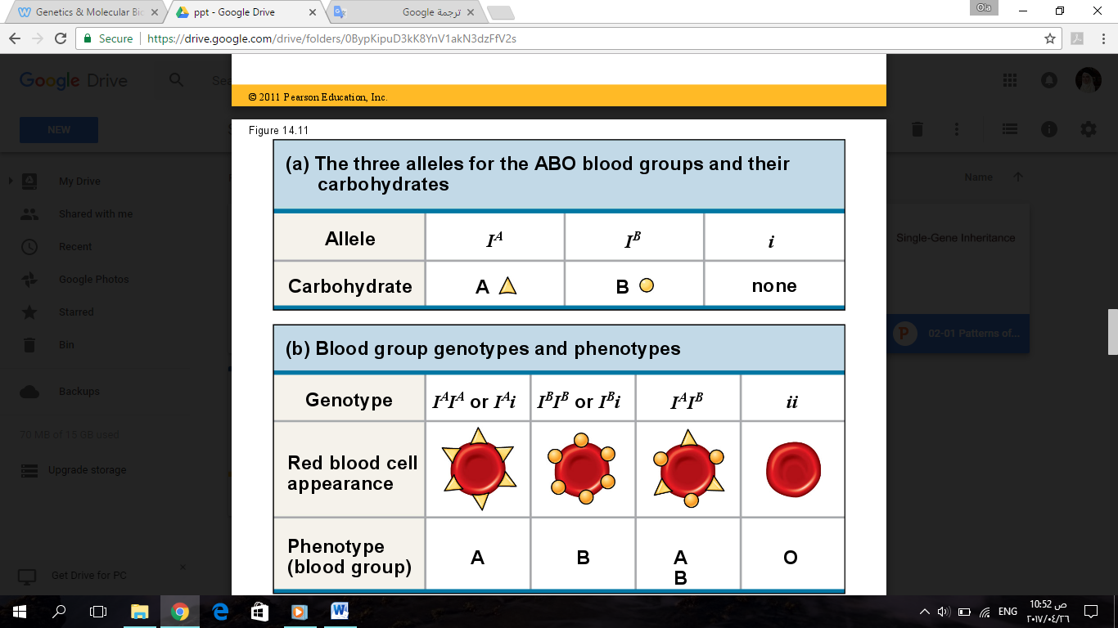

***Pleiotropy***

Pleiotropy means that there are multiple phenotypic effects from a single gene.

**Example:** cystic fibrosis

* Normally, a membrane protein (a chloride ion channel) plays a role in the transport of chloride (Cl-) through the membrane. When this protein is defective, Cl- is built up outside the cell. This results in mucus buildup in the lumens of several organs.
* 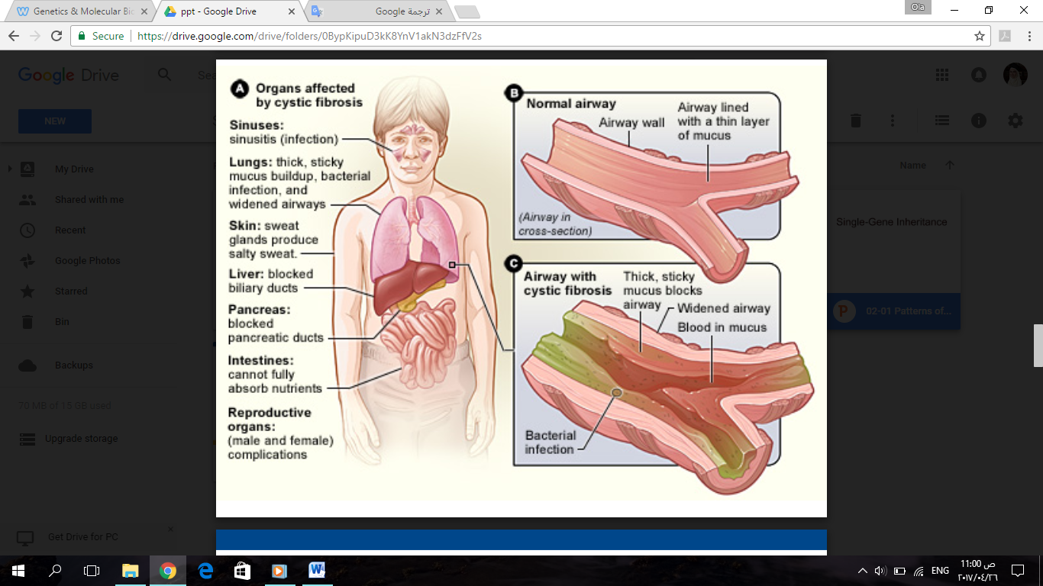The gene that encodes for this chloride channel is called **CFTR**.
* **Clinical features:**
  + - Buildup of mucus in the sinuses, lung, trachea, intestines and other organs.
    - The mucus is prone to infections causing sinusitis, infection in the lungs.
    - Sweating, chloride is high in the skin.
    - The bile duct and the pancreatic duct are blocked because they're filled with mucus.
    - Intestines cannot fully absorb nutrients because of the mucus lining the lumen.
    - Male and female complications in the sexual organs because their lumens are filled up with mucus.
* A single gene (CFTR) is affecting multiple systems >> Pleiotropy.

***Epistasis***

In epistasis, one gene on one locus is influencing a second gene on another locus.

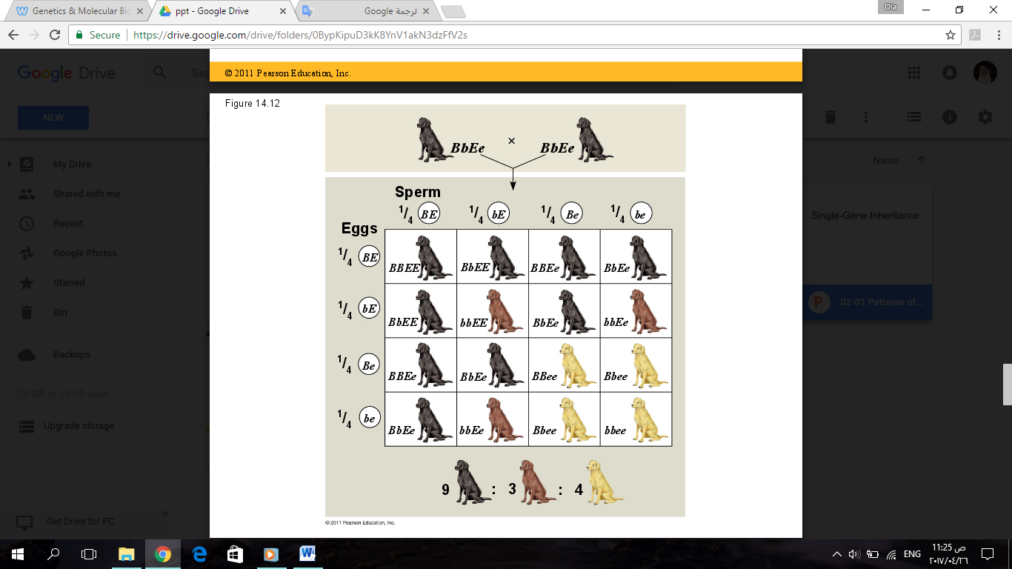**Example:** The coat color of Labrador retrievers

The black color (B) is dominant over the brown (b). BB or Bb > black, bb >brown. There is another gene somewhere else (E). When it's homozygous recessive (ee), it will prevent the pigmentation from happening; neither the brown nor the black color will show up and the dog is colorless. This is epistasis; one gene on one locus (e) is influencing a second gene on another locus (B/b).

Polygenic Inheritance

Single gene disoreders are rare. Polygenetic disorders are more common.

In polygenic inheritance, the phenotype is influenced by many genes. Examples: cancer, cardiovascular diseases and diabetes. There is no single gene that is causing the disorder; different genes are under risk. When one of the genes is mutated, the individual is at risk of having the disease.

***Nature and Nurture: The Environmental Impact on Phenotype***

**Multifactorial characters:** genetic and environmental factors collectively influence phenotype (gene-environment interaction). Many disorders are multifactorial. For example: someone who is heterozygous for LDL receptor will have higher blood cholesterol levels than someone who is homozygous normal. But his diet also controls its level in blood. Other examples: cancer, diabetes, and cardiovascular diseases.

When I have a mutifcatorial disorder, this means that many genes and environmental factors are influencing the phenotype.

The features of multifactorial diseases have a normal distribution (bell curve shape).

**Example:** skin color

There are 3 genes for skin color; each of them participates in skin color. Each gene has two alleles. For example, I might have a dark allele and a light allele for gene1, two dark alleles for gene2, and a dark allele and a light allele for gene3. There are a lot of possibilities creating a spectrum of colors. It is not binomial; not black or white.

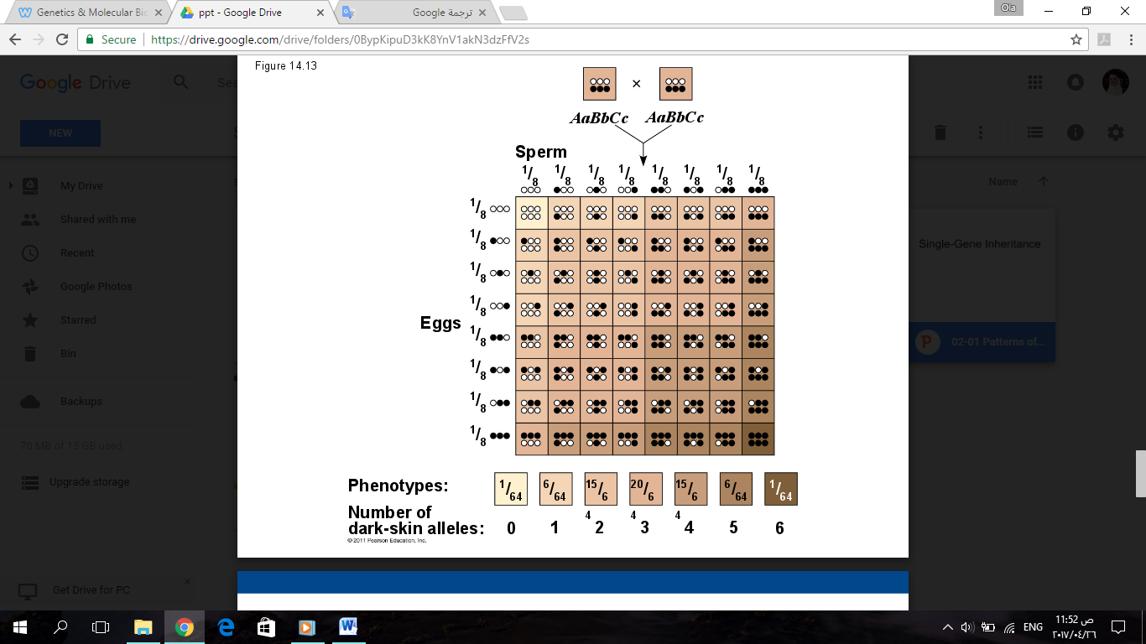

41:20-53:30

*The End*

*Good Luck*